Adventure Works Internet Sales Analysis and Growth Recommendations

Zi (Zoey) Ye

3 November 2026

Executive Summary
Adventure Works should focus its Internet sales strategy on bicycles while testing opportunities to sell complementary accessories and clothing. Across the observation period, recorded sales totaled 29,358,677.22. Bicycles contributed 96.46% of this amount, with an average selling price of 1,862.42 per unit. The United States and Australia together accounted for 62.85% of recorded sales. Homeowners spent 8.70% more per customer than non-homeowners, but this descriptive difference does not justify using home ownership alone to select marketing audiences. Recommendations should also account for incomplete years, a changing product mix, and uncertainty about currency comparability.

Introduction
Adventure Works wants to understand its Internet sales and identify where to direct resources for future growth. This report examines sales by country, year, and product category; compares customer income across countries and genders; and evaluates purchasing differences by home ownership. The dataset contains 60,398 sales line items representing 27,659 orders and 18,484 customers. Its order dates range from December 29, 2010, to January 28, 2014. Each row represents an order line, so row counts are not treated as order counts. The findings guide growth recommendations, but the analysis does not identify causal relationships.

Key Issues and Goals
The main issue is how Adventure Works can grow Internet sales while allocating its resources effectively. A high sales total identifies an established market, but it does not show whether additional marketing spending will be profitable. Rapid percentage growth from a small base may add little revenue. The analysis therefore considers sales levels, changes over time, product prices, and customer purchasing measures together. Spending per customer is compared across home ownership groups to account for their different sizes.

Decision Criteria
The preferred strategy should build on a substantial revenue opportunity and provide a practical way to measure results. The strategy is assessed using revenue contribution, growth across comparable years, and spending per customer. Before expanding a campaign, leadership should assess whether additional revenue covers acquisition, product, and fulfillment costs. Strategies that can be tested with a limited budget are preferable to broad spending commitments based only on historical sales.

Assumptions and Data Limitations
The analysis was completed in Python using Google Colab. Internet sales are measured as the sum of SalesAmount. OrderDate is used to identify the sales year, and SalesOrderNumber is used to count orders. Customer income statistics count each customer once, preventing frequent purchasers from receiving additional weight. Checks found no repeated combinations of sales order number and line number, and customer country, gender, and income were consistent across repeated records. Records were retained when missing values affected only nonessential fields, such as titles, middle names, or tracking numbers.
Only 2011–2013 cover complete calendar years. The dataset contains three days in 2010 and January 1–28 in 2014, so these partial years are reported but excluded from full-year growth comparisons. Product categories were constructed from product names because the file does not contain a category field. Names beginning with Mountain-, Road-, or Touring- were classified as bicycles, clothing items as clothing, and the remaining identified cycling supplies as accessories. All products were assigned under these rules. Monetary comparisons assume that recorded sales and income values have comparable currency bases. However, the file contains multiple CurrencyKey values without an accompanying exchange-rate table or currency documentation, so this assumption should be verified before budget decisions. Amounts are therefore reported without assigning a currency symbol.

Data Analysis

Sales by Country and Year
Sales fell 17.43% in 2012 before rising 179.87% to 16,351,550.34 in 2013 (Table 1). Every country recorded higher sales in 2013 than in 2012. Across the observation period, the United States generated the highest total, 9,389,789.51, followed by Australia at 9,061,000.58. Australia led in 2011 and 2012, while the United States ranked first in 2013. Table 1 reports each country’s sales for every observed year, and Figure 1 compares the three complete years. These findings identify the largest existing markets, but do not establish which market offers the best return on additional investment.

Table 1. Internet Sales by Country and Year
Country | 2010 | 2011 | 2012 | 2013 | 2014 | Total
Australia | 20,909.78 | 2,563,732.25 | 2,128,407.46 | 4,339,443.38 | 8,507.72 | 9,061,000.58
Canada | 3,578.27 | 571,571.80 | 307,604.52 | 1,085,632.65 | 9,457.62 | 1,977,844.86
France | 3,399.99 | 410,845.33 | 648,065.54 | 1,578,511.80 | 3,195.06 | 2,644,017.71
Germany | 0.00 | 520,500.16 | 608,657.98 | 1,761,876.36 | 3,277.83 | 2,894,312.34
UK | 699.10 | 550,591.22 | 712,700.96 | 2,124,007.29 | 3,713.64 | 3,391,712.21
US | 14,833.90 | 2,458,285.17 | 1,437,048.73 | 5,462,078.86 | 17,542.85 | 9,389,789.51
Total | 43,421.04 | 7,075,525.93 | 5,842,485.20 | 16,351,550.34 | 45,694.72 | 29,358,677.22
Note. UK = United Kingdom; US = United States. The 2010 observations cover December 29-31; the 2014 observations cover January 1-28.

Figure 1. Internet Sales by Country 2011-2013
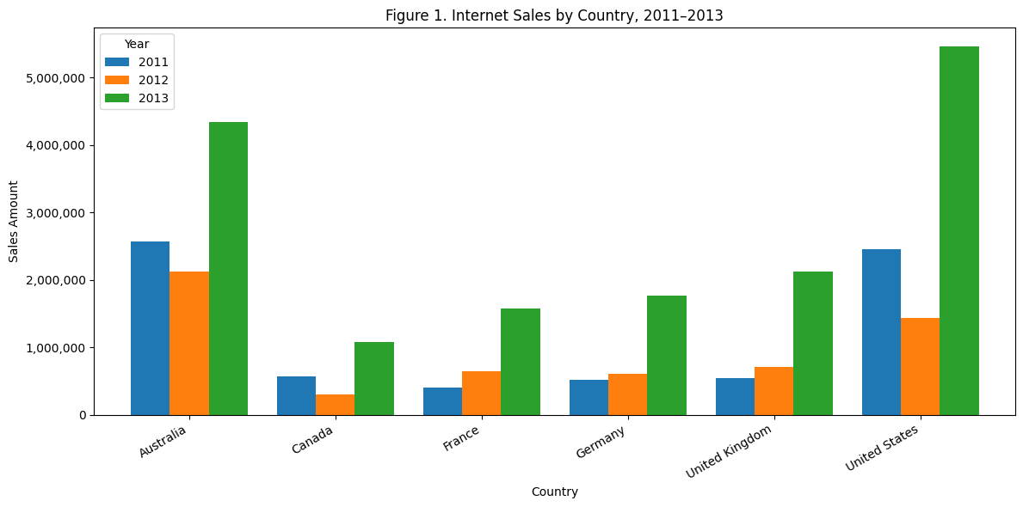
Note. Only complete calendar years are compared.

Customer Yearly Income
Customer income differences were more pronounced across countries than between genders within the same country. Australian women had a mean yearly income of 65,284.19, compared with 63,412.35 for Australian men. In France, the corresponding means were 35,341.55 and 36,172.30. Minimum income was 10,000 in every group, while maximum income ranged from 110,000 to 170,000. The United Kingdom had the largest standard deviations: 48,288.44 for women and 48,593.22 for men. In both UK gender groups, mean income was approximately 52,000, compared with a median of 30,000, consistent with a right-skewed distribution. Table 2 provides the full statistics. These results describe customers who purchased in the dataset; they do not establish that income or gender causes purchasing differences.
Table 2. Customer Yearly Income by Country and Gender
Panel A. Customer counts and central tendency
Country / gender | Customers | Mean | Median
Australia / F | 1,777 | 65,284.19 | 70,000.00
Australia / M | 1,814 | 63,412.35 | 70,000.00
Canada / F | 767 | 56,505.87 | 60,000.00
Canada / M | 804 | 57,798.51 | 60,000.00
France / F | 893 | 35,341.55 | 30,000.00
France / M | 917 | 36,172.30 | 30,000.00
Germany / F | 874 | 43,810.07 | 30,000.00
Germany / M | 906 | 42,108.17 | 30,000.00
UK / F | 934 | 52,184.15 | 30,000.00
UK / M | 979 | 52,155.26 | 30,000.00
US / F | 3,888 | 63,276.75 | 60,000.00
US / M | 3,931 | 63,953.19 | 60,000.00
Panel B. Income range and sample standard deviation
Country / gender | Minimum | Maximum | Standard Deviation
Australia / F | 10,000.00 | 160,000.00 | 31,164.36
Australia / M | 10,000.00 | 170,000.00 | 32,450.71
Canada / F | 10,000.00 | 170,000.00 | 19,181.55
Canada / M | 10,000.00 | 170,000.00 | 21,214.77
France / F | 10,000.00 | 110,000.00 | 26,915.85
France / M | 10,000.00 | 110,000.00 | 27,633.45
Germany / F | 10,000.00 | 130,000.00 | 35,715.76
Germany / M | 10,000.00 | 130,000.00 | 35,277.49
UK / F | 10,000.00 | 170,000.00 | 48,288.44
UK / M | 10,000.00 | 170,000.00 | 48,593.22
US / F | 10,000.00 | 170,000.00 | 25,166.56
US / M | 10,000.00 | 170,000.00 | 26,228.43
Note. Each customer is counted once; income is available for every customer. F = female; M = male. Standard deviations use the sample formula.

Product Categories and Average Prices
Bicycles generated the highest sales revenue, totaling 28,318,144.65, or 96.46% of recorded sales. Their quantity-weighted average unit price was 1,862.42, calculated by dividing the sum of UnitPrice multiplied by OrderQuantity by total units sold. Accessories generated 700,759.96, while clothing generated 339,772.61. Accessories sold more units than bicycles (36,092 versus 15,205), but their average price of 19.42 resulted in a much smaller revenue contribution (Table 3).

Table 3. Sales and Average Price by Product Category
Category | Sales | Units | Sales share | Avg. price
Bikes | 28,318,144.65 | 15,205 | 96.46% | 1,862.42
Accessories | 700,759.96 | 36,092 | 2.39% | 19.42
Clothing | 339,772.61 | 9,101 | 1.16% | 37.33
Note. Categories were constructed from names; prices are weighted by units sold. Percentages may not sum to 100% because of rounding.

Annual Changes in Product Sales
Bicycle sales increased from 5,839,695.33 in 2012 to 15,359,502.36 in 2013, an increase of 163.02%. Accessories and clothing recorded exceptionally high growth rates because their 2012 sales were only 2,147.08 and 642.79, respectively. The data do not establish whether the changes reflect product availability, customer demand, or differences in coverage. The absence of recorded bicycle sales during the partial 2014 period does not establish that demand disappeared. Table 4 and Figure 2 show the annual category results.

Table 4. Internet Sales by Year and Product Category
Year | Accessories | Bikes | Clothing | Total
2010 | 0.00 | 43,421.04 | 0.00 | 43,421.04
2011 | 0.00 | 7,075,525.93 | 0.00 | 7,075,525.93
2012 | 2,147.08 | 5,839,695.33 | 642.79 | 5,842,485.20
2013 | 668,241.53 | 15,359,502.36 | 323,806.45 | 16,351,550.34
2014 | 30,371.35 | 0.00 | 15,323.37 | 45,694.72
Note. The 2010 and 2014 observations cover partial years.

Figure 2. Sales by Product Category 2011-2013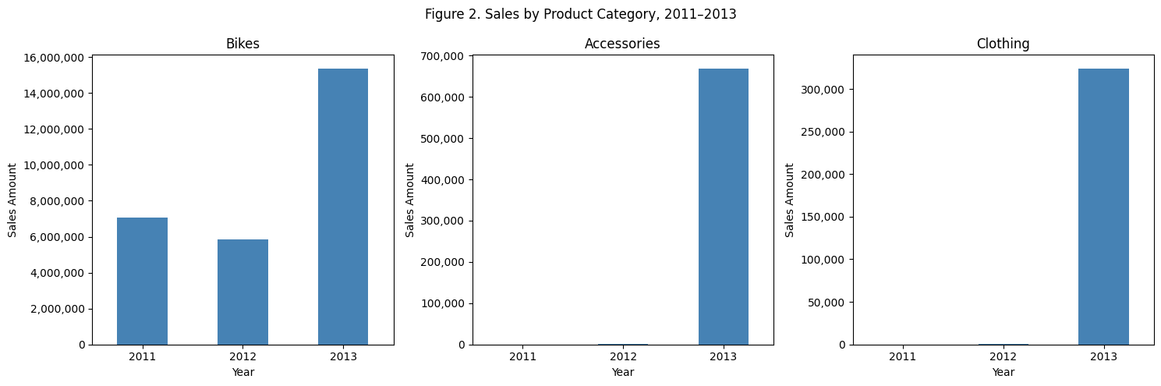

Home Ownership and Purchasing
Homeowners generated 20,385,349.80 in sales, compared with 8,973,327.42 for non-homeowners. However, there were also more homeowners: 12,502 customers compared with 5,982. Homeowners spent an average of 1,630.57 per customer during the observation period, versus 1,500.05 for non-homeowners, a difference of 8.70%. They placed slightly more orders per customer, 1.52 versus 1.44, and had a slightly higher average order value, 1,069.65 versus 1,043.29. Their median cumulative spending was also higher, at 342.00 versus 209.96. Table 5 and Figure 3 show an association rather than a causal effect. Statistical significance was not tested, and income, country, and time observed may contribute to the differences.

Table 5. Customer Spending by Home Ownership
Measure | Non-homeowner | Homeowner
Customers | 5,982 | 12,502
Total sales | 8,973,327.42 | 20,385,349.80
Mean spending per customer | 1,500.05 | 1,630.57
Median spending per customer | 209.96 | 342.00
Total orders | 8,601 | 19,058
Orders per customer | 1.44 | 1.52
Average order value | 1,043.29 | 1,069.65
Note. Spending is cumulative; average order value equals sales divided by distinct orders.

Figure 3. Customer Purchasing by Home Ownership
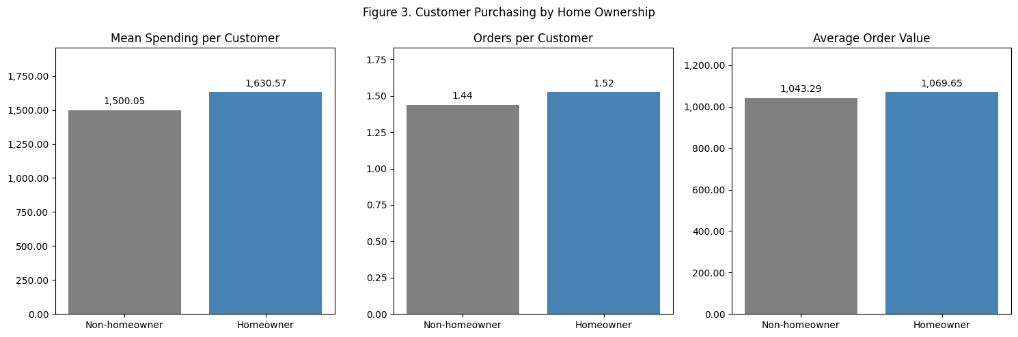
Note. Differences are descriptive and do not establish causation.

Preferred Alternative and Rationale
Adventure Works should prioritize bicycle sales in the United States and Australia and test recommendations for complementary products. This approach builds on the company’s largest observed revenue sources. Leadership could first test clearer bicycle specifications, sizing information, and checkout improvements to determine whether they increase completed purchases. Product recommendations could offer relevant helmets, bottles, maintenance supplies, or clothing alongside a bicycle purchase. Focusing mainly on accessories and clothing would rely on a much smaller revenue base, while focusing on homeowners would place too much weight on a modest, unadjusted difference. Most initial resources should support bicycle sales, with a smaller test budget for accessory and clothing recommendations.

Recommendations and Expected Outcomes
Higher bicycle conversion and more complementary purchases could increase revenue, but their effect on profit must be tested. Each change should be tested against a concurrent control group. Outcomes should include conversion rate, average order value, accessory attachment rate, and contribution profit after relevant costs. A 1% increase in recorded 2013 bicycle revenue would equal approximately 153,595.02 before additional costs; this illustrates scale rather than providing a forecast. Leadership should expand an initiative only when its incremental profit supports the spending. Follow-up campaigns should use prior purchases and product interests rather than home ownership alone.

Conclusion
Given the revenue concentration in bicycles and the size of the US and Australian markets, Adventure Works should test ways to increase bicycle purchases and complementary sales. Home ownership shows a modest purchasing association, but should not determine marketing priorities alone. Leadership should verify currency comparability, compare matched periods, and measure incremental profit before expanding spending.

Appendix
Table A1. Order Date Coverage by Year
Year | First order | Last order | Sales lines
2010 | 2010-12-29 | 2010-12-31 | 14
2011 | 2011-01-01 | 2011-12-31 | 2,216
2012 | 2012-01-01 | 2012-12-31 | 3,397
2013 | 2013-01-01 | 2013-12-31 | 52,801
2014 | 2014-01-01 | 2014-01-28 | 1,970

